2016 Alphabet Antics Sponsorship
Sept. 26, 2016 – 6:30-9 p.m. -- St. Stephen’s Lutheran Church, Tallahassee, Florida

Sponsor (as listed table/program/Facebook):

Contact Person: Phone:

Mailing address:

Email/Website:

Sponsorship Category: Amount:

Sponsor Signature __________________________________________ Date________________________

A-List | $200 | - Includes 4 tickets to Alphabet Antics  (Tickets will be held at Will Call.)  - Your name/business name on a game table  - A-Lister in our event program and Facebook
Extraordinary | $5 each/vowel  $1 each/consonant | Buy letters of your name and/or business to be listed in the event program and on Facebook as our Extraordinary Supporter of Literacy
Imaginative | $100 | Imagine how you’ll feel to see your business-card-size advertisement in our event program.
Openhearted | In-Kind, Gift Cards, Cash | Donate four prizes for 1^{st-}, 2^{nd-} or 3rd-place team; name announced in our event program & at event as our Openhearted Supporter of Literacy
Unique | Any Amount | Give a cash donation to Literacy Volunteers of Leon County; be listed in our event program as our Unique Supporter of Literacy

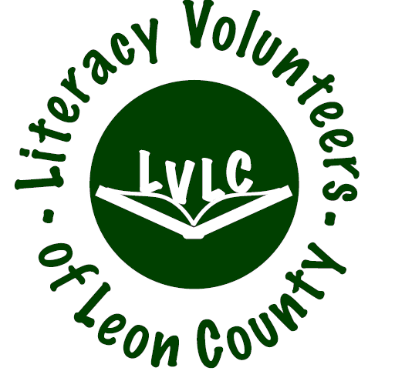
Please mail a copy of signed form with your check to Literacy Volunteers of Leon County, 200 W. Park Ave., Tallahassee, FL 32301-7720
850-606-2644 -- literacy@leoncountyfl.gov -- http://www.literacyvolunteersleon.org

